Android WifiConfig App User Guide

V 1.0

2018/10/22

Revision History

|  |  |  |  |  |
| --- | --- | --- | --- | --- |
| Date | Version | Comments | Author | Reviewer |
| **2018/10/22** | v 1.0 | draft | Neil_Zhou |  |

Contents

Revision History 2

Contents 3

1 Search Devices View 4

2 AP List View 5

3 Connect to an AP 6

4 Disconnect to an AP 7

# Search Devices View

When you start this app, you should get into the searching devices view. After you click a device, the app will build a gatt connection to that device. Slip the connected device item to left and click “disconnect”, you can disconnect the gatt connecting. As shown below:

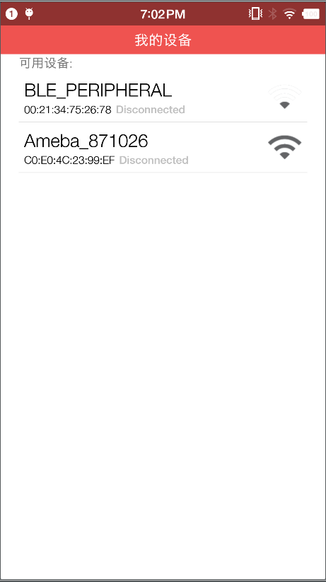 

Figure ‑ Search devices view

# AP List View

After connected to a device, you can get into the AP list view by click the connected device again. Once you get into the view, it will send a command and list the searched aps. Sliding down the view and it will be refreshed again. As shown below:

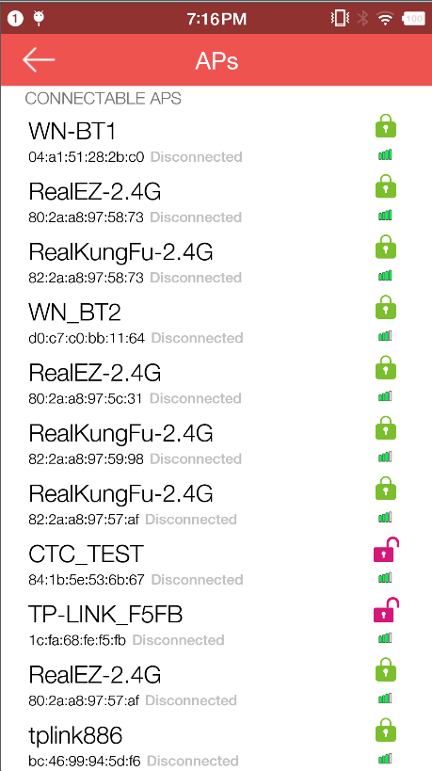 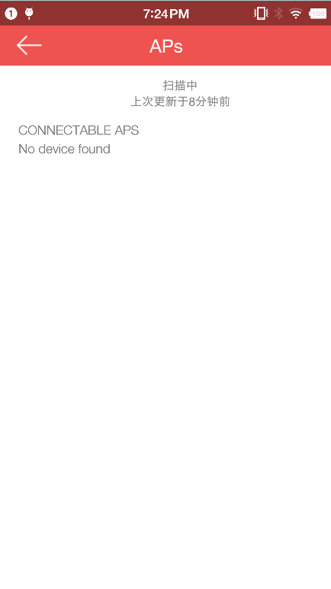

Figure ‑ AP list view

## 

# Connect to an AP

Once get the AP list, if you can connect to an AP just by click it. If this AP need password, the app will pop up an input box and let you enter the password. As shown below:

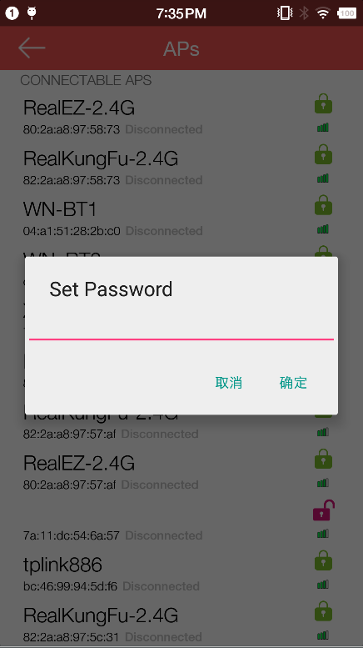 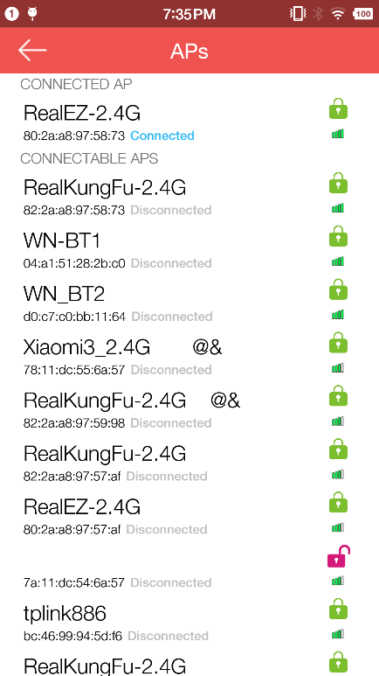

Figure ‑ Connect to an AP

# Disconnect to an AP

By sliping the connected AP item to left and click “disconnect”, you can disconnect to an connected AP. As shown below:

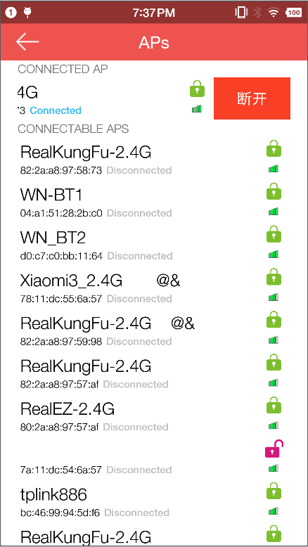

Figure ‑ Disconnect to an AP